

Dear Artists,

Thank you for the collaboration with the Opera Gallery regarding the Polish Contemporary Art Exhibition in April 2009.
We have received a lot of thanks and positive critics from the audience. In general we consider the show as a great success.
The exhibition was announced by the Budapest Exit Magazine and the Pesti Est Program Magazine. The days after the opening reception, the gallery has been visited by art-school groups and by many art lovers.
It was very hard to do the individual artists justice within the confines of this exhibition, but the Award Committee of the Europa Authentica after many considerations will prize Barbara Palka-Winek with the Artis Laudabilis Award, for showing us through the complexity of her artworks the total harmony between reality and abstraction.

The Polish Contemporary Art Exhibition has been followed up by the Hungarian Television and other important media. The TV report we will load up on the web site in the next days and you will receive the exhibition catalogues together with the artworks.

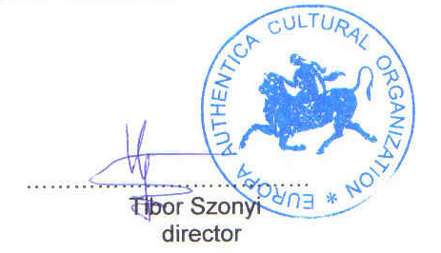

Budapest, 2009-05- 05

